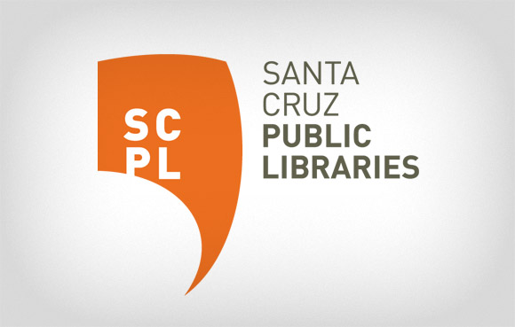
FOR IMMEDIATE RELEASE

CONTACT:
Janis O’Driscoll, 831- 427-7700, x7662
odriscollj@santacruzpl.org

Advisory Committee for Proposed Downtown Library Branch Renovation
What will the Downtown Branch Need in the Next Twenty Years?

MAY 8, 2017—SANTA CRUZ, CA—The Santa Cruz Public Library System, a network of 10 neighborhood library branches throughout Santa Cruz County, today announced that a Downtown Branch Library Advisory Committee has been formed to assist the Library and the City in developing a space that meets the community’s needs and desires for 21st Century library programming.

The renovation/reconstruction of the Downtown Branch will be made possible with funds available from Measure S, a library facilities bond measure approved by 70% of the voters in June 2016.

The Advisory Committee will study recently developed public library buildings, review staff input and current use, as well as examine the broader community’s interests and needs. The Committee will also be considering possible locations for the renovated/new Downtown Branch.

The ten-member group, appointed by Santa Cruz Public Libraries Director Susan Nemitz, represents a variety of ages, work experience, and life experience in our community.

Regarding the new committee, Santa Cruz Mayor Cynthia Chase stated that “as the Mayor and a member of the community, I am thrilled to see such a diverse group of the public serve come together to work on the future library design and programming. I also encourage the community to participate in this process to ensure that the final product meets our collective needs.”

Appointed to the Committee are: Steve Blair, Linda Craighead, Martha Dexter, Rena Dubin, Martin J. Gomez, Elise Granata, Yolanda Henry, Nikolara Jansons, Tera Martin, and Teresa Thomae.

The City and the Library are now engaged in the selection of an architectural firm to lead a public information-gathering process and support the Advisory group as it prepares the building program.

All meetings of the Committee will be public and the community is encouraged to attend and contribute. A meeting schedule has not yet been developed but will be announced as soon as it is available. The work of the Committee will also be tracked on the Library’s website: https://www.santacruzpl.org/measure_s/

The Library, the City, and the Committee are excited to begin this work.

About the Santa Cruz Public Library System
The Santa Cruz Public Libraries (SCPL) system delivers information, education, enrichment and inspiration through a network of 10 neighborhood library branches, a web-based digital library, a Bookmobile and community-based programs. SCPL serves children, teens and adults with innovative programming, professional services and community facilities that spark imagination and support discovery. Residents can explore a wide range of interests from academic research, book clubs and literacy programs to digital photography, locally-produced music and local history. Branch locations include Aptos, Boulder Creek, Branciforte, Capitola, Downtown Santa Cruz, Felton, Garfield Park, La Selva Beach, Live Oak and Scotts Valley. Learn more about SCPL at SantaCruzPL.org or via Facebook, Instagram, Pinterest, Twitter and YouTube.

###

