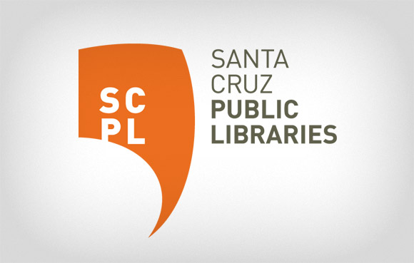
FOR IMMEDIATE RELEASE

CONTACT:
Janis O’Driscoll, 831- 427-7700, x7662
odriscollj@santacruzpl.org

Downtown Branch Library Renovation Committee Sets First Meeting
Citizen Group Begins Its Work

JUNE 2, 2017—SANTA CRUZ, CA—The Santa Cruz Public Library System today announced that the citizen Downtown Branch Library Advisory Committee has set its first meeting.

The Committee, formed to assist the Library and the City in developing a written building program outlining the branch’s space needs over the next twenty years, will meet on Wednesday, June 14 in the Santa Cruz City Council Chambers at 6:30pm.

“We are eager to explore all the possibilities,” commented Director of Libraries, Susan Nemitz. “And we are grateful to the Committee members who are volunteering their time to do this important work,” she added.

The Advisory Committee will study recently developed public library buildings, review staff input and current use, as well as examine the broader community’s needs. The Committee will also be considering possible locations for the renovated/new Downtown Branch. Community comment is welcomed during this public process.

Following the meeting on June 14, the Committee expects to meet twice a month every 2nd Wednesday and 4th Thursday, and to prepare a report for the Library Joint Powers Board in November 2017. Subsequent meetings will be held in the Downtown Branch meeting room at 224 Church Street in Santa Cruz. The July 12th meeting will be held at the new Los Gatos Public Library in Los Gatos as part of its exploration of 21st Library concepts.

All meetings of the Committee will be public and the community is invited to attend and contribute. The work of the Committee will also be tracked on the Library’s website: https://www.santacruzpl.org/measure_s/

About the Santa Cruz Public Library System
The Santa Cruz Public Libraries (SCPL) system delivers information, education, enrichment and inspiration through a network of 10 neighborhood library branches, a web-based digital library, a Bookmobile and community-based programs. SCPL serves children, teens and adults with innovative programming, professional services and community facilities that spark imagination and support discovery. Residents can explore a wide range of interests from academic research, book clubs and literacy programs to digital photography, locally-produced music and local history. Branch locations include Aptos, Boulder Creek, Branciforte, Capitola, Downtown Santa Cruz, Felton, Garfield Park, La Selva Beach, Live Oak and Scotts Valley. Learn more about SCPL at SantaCruzPL.org or via Facebook, Instagram, Pinterest, Twitter and YouTube.

###

